1. **Naan bread with homemade walnut-bell pepper dip**

Recipe by food blogger Inneke De Kimpe (instagram.com/inneke_de_kimpe)

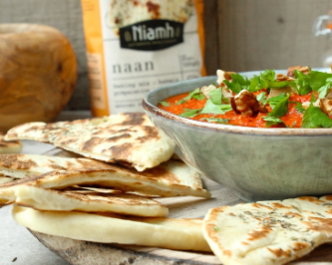

**ingredients**   
  
**for 12 naan breads**

* 500 g Mix for naan bread
* 280 ml water (room temperature)
* 25 ml olive oil
* Dried thyme
* When working on your dough, always sprinkle flour over the work surface/roll of dough/dough.

**for the bell pepper dip**

* 1 jar of grilled bell peppers
* 1 clove of garlic
* 30 g walnuts
* 1 tbsp olive oil
* ½ tsp cinnamon
* ½ tsp ground coriander
* ½ tsp ground cumin
* Salt and pepper

**for the garnish**

* Several sprigs of flat-leaf parsley and a few walnuts

**preparation**

**make the naan bread**

1. Add mix, water, and oil together and knead for 5 minutes by hand or in a food processor until you have a smooth dough.
2. Cover the dough with a tea towel. Leave to rise at room temperature for 60 minutes. Divide the dough into 12 pieces and shape them into balls. Cover and leave to rise at room temperature for 10 minutes.
3. Roll the balls of dough out into an oval shape (12 cm x 18 cm). Sprinkle some thyme over the dough. Place an anti-stick pan over medium heat. Fry until both sides of the naan are golden brown.
4. Cut each naan into triangles.

**make the bell pepper dip**

1. Mix all the ingredients in a blender until smooth.
2. Serve in a decorative bowl and garnish with the flat-leaf parsley and a few walnuts.
3. **Blinis with homemade avocado cream, smoked salmon and mango**  
   Recipe by food blogger Inneke De Kimpe (instagram.com/inneke_de_kimpe)

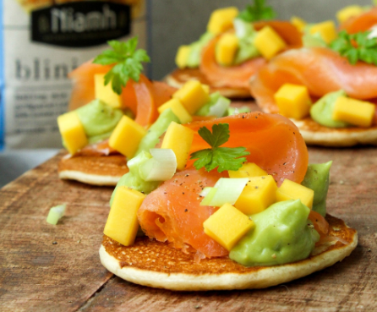

**for 12 blinis**

* 125 g Mix for blinis (1/4 pack)
* 220 ml semi-skimmed milk (room temperature)

**for the avocado cream**

* 1 avocado
* Juice of 1/2 lemon
* Garlic powder
* 1 spring onion
* Salt and pepper

**for the garnish**

* 150 g smoked salmon
* 1/2 mango
* Several sprigs of flat-leaf parsley
* Pepper

**preparation**

**make the blinis**

1. Combine the mix and milk, stirring until you have a smooth batter.
2. Cover the bowl with cling film. Leave to rise at room temperature for 30 minutes. Place a greased anti-stick pan over medium heat. Fry the blinis, making them as large or small as you like, for about 2 minutes until they are golden brown on both sides.

**make the avocado cream**

1. Place the avocado in a blender and add the lemon juice, salt, pepper and garlic powder.
2. Finely chop the spring onion and add it to the avocado cream.

**garnish the blinis**

1. Cut the mango into small cubes.
2. Arrange the blinis on a decorative platter, garnish with the avocado cream and smoked salmon and top with the mango cubes, springs of flat-leaf parsley and some pepper.
3. **Focaccia with homemade sun-dried tomato tapenade, fried chicken and parmesan**

Recipe by food blogger Inneke De Kimpe (instagram.com/inneke_de_kimpe)

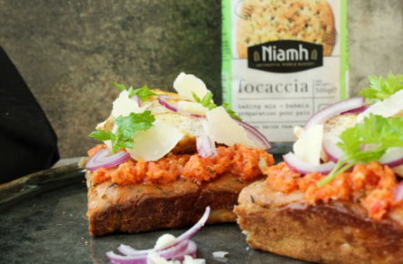

**ingredients for 4 toasts**  
  
**for 1 focaccia**

* 500 g Mix for focaccia
* 400 ml water (room temperature)
* 20 ml olive oil

**for the tomato tapenade**

* 10 sun-dried tomatoes
* 1 clove of garlic
* 1 tbsp olive oil
* 1 tbsp parmesan
* Salt and pepper

**for the chicken**

* 1 chicken breast fillet
* Poultry seasoning, turmeric, salt, pepper and paprika powder

**for the garnish**

* ¼ red onion
* Finely chopped, fresh thyme
* Several shavings of parmesan

**preparation**

**make the focaccia**

1. Add mix, water, and oil together and knead for 6 minutes using a food processor or for 10 minutes using a hand mixer until you have a soft dough.
2. Cover the bowl with cling film. Leave to rise at room temperature for 30 minutes.
3. Place the dough into a greased baking tray or greased rectangular baking tin.
4. Moisten your hands with oil and spread the dough into a rectangle (25 cm x 35 cm). Brush the dough with olive oil. Leave to rise, uncovered, at room temperature for 30 minutes.
5. Bake the focaccia for 20-25 minutes in an oven preheated to 215°C. Let the focaccia cool.

**make the tomato tapenade**

1. Place the sun-dried tomatoes, garlic, olive oil, parmesan cheese, salt and pepper into a blender. Mix well.

**fry the chicken**

1. Season the chicken with poultry seasoning, turmeric, salt, pepper and paprika powder.
2. Fry the chicken until it is golden brown.
3. Slice the chicken fillet.

**garnish the focaccia**

1. Slice the red onion into fine rings.
2. Cut the focaccia into small rectangles and spread some tapenade on each one.
3. Arrange the slices of chicken and red onion on the focaccia.
4. Garnish with parmesan shavings and fresh herbs.
5. **Turkish bread with homemade olive tapenade, tomato and feta**

Recipe by food blogger Carolien Vreysen (instagram.com/onahealthyadventure)

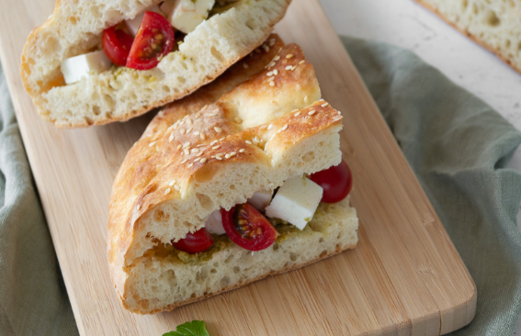

**ingredients**

**for 1 pide bread**

* 250 g Mix for pide (1/2 pack)
* 155 ml chilled water (chilled in the refrigerator)
* 25 g regular flour
* 50 ml water (room temperature)
* When working on your dough, always sprinkle flour over the work surface/roll of dough/dough.

**for the olive tapenade**

* 50 g olives
* 1 tbsp olive oil
* Coarsely ground pepper
* Salt

**for the garnish**

* Cherry tomatoes or vine tomatoes
* Feta (Turkish, if possible)

**preparation**

**make the bread**

1. Add the mix and chilled water together and knead for 10 minutes by hand or in a food processor until you have a smooth dough. Make sure the dough temperature remains below 25°C.
2. Shape the dough into a ball. Cover with a tea towel. Leave to rise at room temperature for 10 minutes.
3. Roll each dough ball out into a rectangle (25 cm x 15 cm). Place them on a baking tray lined with parchment paper. Cover and leave to rise at room temperature for 25 minutes.
4. Mix the regular flour and water into a porridge-like consistency. Brush a portion of this mixture over the dough.
5. Moisten your fingers with the rest of the paste. Make a check pattern by pushing your fingers very deep into the dough.
6. Bake the pide for 25 minutes in an oven preheated to 190°C.

**make the olive tapenade**

1. Place the olives, olive oil, salt and pepper into a blender and mix until smooth.

**garnish the bread**

1. Cut the tomatoes into wedges.
2. Cut the bread into quarters and cut each quarter in half crosswise to open. Spread a layer of olive tapenade on each and then add feta and tomato.